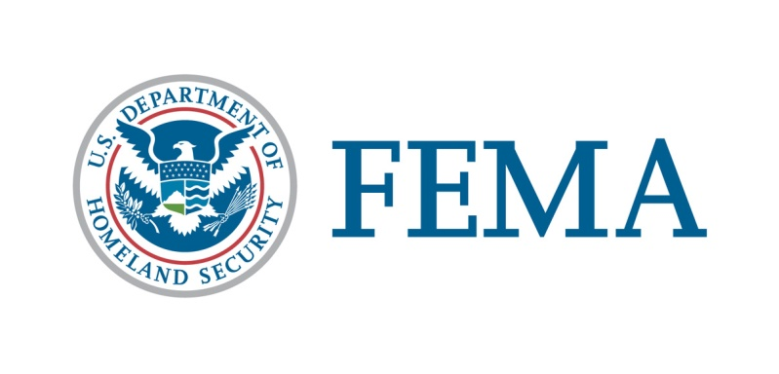

##### Congressional and Intergovernmental Affairs Division

202-646-4500

**State of Iowa**

**Federal Disaster Declaration Fact Sheet**

**April 30, 2020**

On March 23, 2020, President Donald J. Trump granted a Major Disaster Declaration for the State of Iowa triggering the release of Federal funds to help communities recover from COVID-19 that occurred January 20, 2020, and continuing. **This disaster declaration has been amended as indicated below in bold.** Details of the disaster declaration and assistance programs are as follows:

Declaration Number:                                                           FEMA-4483-DR

Incident:                                                                               COVID-19

Incident Period:                                                                   January 20, 2020, and continuing

Federal Coordinating Officer:                                              Paul Taylor

**Individual Assistance (IA**):                                                    (Assistance to individuals and households):

**IA-Designated Areas:                                                              The Crisis Counseling Program for all areas in the State of Iowa.**

Public Assistance (PA):                                                        (Assistance for emergency work and the repair or replacement of disaster-damaged facilities):

PA-Designated Areas:                                                                Emergency protective measures (Category B) not authorized under other Federal statutes, including direct federal assistance, under the Public Assistance program at 75 percent federal funding for all areas in the State of Iowa.

OTHER:                                                                                   Additional designations may be made at a later date if requested by the State and warranted by the results of further assessments.

###