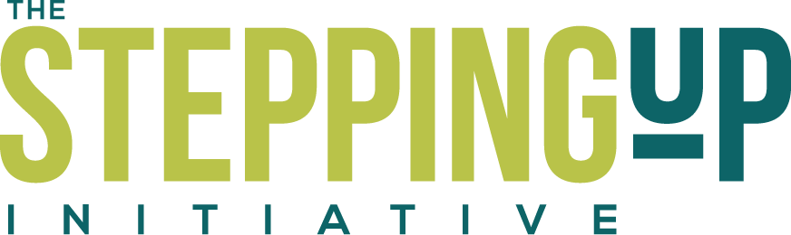
Iowa Stepping Up Summit
October 24, 2018
Hy-Vee Hall, Des Moines

Tentative Agenda

8:30 am - 9:00 am Registration and Morning Refreshments

9:00 am - 9:15 am Welcome and Opening Remarks
Bill Peterson, ISAC Executive Director
Tony Thompson, Black Hawk County Sheriff
Jason Sandholdt, Marion County Sheriff

9:15 am - 9:30 am Johnson & Johnson HealthCare Systems Inc.
Ron Kuntz, Product Market Access & Reimbursement

9:30 am - 10:30 am Reducing Jail Bookings
Moderator: Nastassia Walsh, NACo
Panelists: Darci Alt, Monica Paulsen, Tony Thompson, Suzanne Watson

10:30 am - 11:15 am Team Introductions and Team Planning

11:15 pm - 12:15 pm Lunch and Keynote Speaker
Matthea Little Smith

12:15 pm - 12:30 pm Break

12:30 am - 1:15 pm Shortening the Jail Length of Stay: Pretrial Public Safety Assessments
Moderator: Nastassia Walsh, NACo
Panelists: Michelle Dix, Teri Somerlot, Tim Larson

1:15 pm - 1:45 pm Team Planning

1:45 pm - 2:00 pm Break

2:00 pm - 2:30 pm Connections to Treatment: SafeNetRx
Moderator: Nastassia Walsh, NACo
Panelists: Steve Johnson, Tiffany Mass, Jon-Michael Rosmann

2:30 pm - 3:00 pm Team Planning

3:00 pm - 3:45 pm Reducing Recidivism
Moderator: Nastassia Walsh, NACo
Panelists: Sara Carter, Elley Gould, Jason Sandholdt

3:45 pm - 4:30 pm Team Conclusions and Team Planning

