**ISAC Spring Conference App**

**Tutorial**





**Step 1:** Search “ISAC App” in the App or Google Play Stores. Our app will show a picture of the ISAC logo. Click to download to app.

**** Skip step 1 and 2 if you have already downloaded the ISAC Association App. The Spring Conference App will be on the ISAC Association App launch page.



**Step 2:** Once you have downloaded and launched the app, make sure to allow our app to send you notifications. This will ensure that you receive important and conference-related updates from ISAC.

A screenshot of a cell phone

Description generated with very high confidence

**Step 3:** Click “View Event.”

***This page will house the ISAC Association App, Spring App, and the future Annual Conference app. You will no longer need to download new apps for each conference.

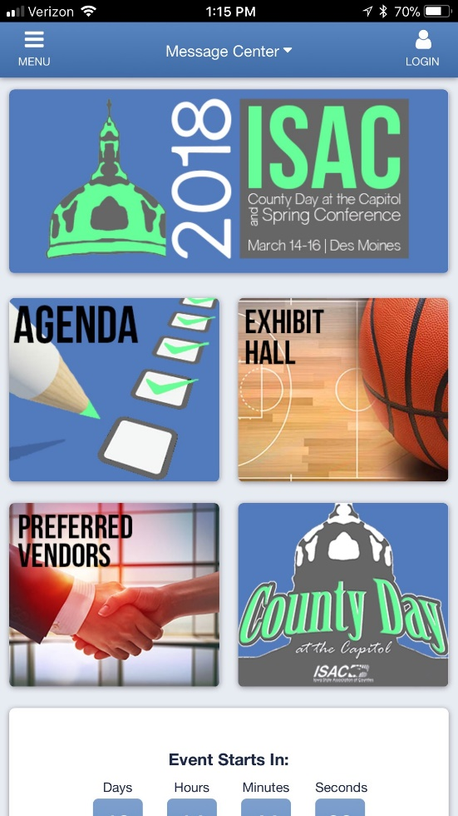

**Step 4:** This is the Spring Conference App home screen. From here you can login and create your profile. Click “Login” in the upper right-hand corner.



**Step 5:** Enter your email address and press “Continue.”



**Step 6:** Enter your first and last name, create a password, and press “Create Account.”

A screenshot of a cell phone

Description generated with very high confidence

**Step 7:** Take a minute to customize your profile. Remember to click “Save your Profile” at the bottom of the screen.

A screenshot of a cell phone

Description generated with very high confidence

**Step 8:** Now that you are in the app take some time to explore its features. Frequently used sections are on the home screen. For more information click “Menu” in the upper left-hand corner.



**Step 9:** The menu tab is where you will find key features. The Agenda, Exhibitors, and Activity Feed are very useful.

*A screenshot of a cell phone

Description generated with very high confidence*

**Agenda:** From the Agenda feature you can add events and meetings to your personal schedule. To add an event. Click “+ Add to Your Schedule.”

A screenshot of a cell phone

Description generated with very high confidence

**Agenda:** The events you add will show up in your upcoming schedule when you click your profile in the upper right-hand corner.



**Activity Feed:** Use the activity feed to share pictures and posts about ISAC meetings, events, and county news.



**Exhibitors:** The exhibitors tab will allow you to see who is exhibiting at the conference and what booth number they are in. Click on any exhibitor to view their profile.



**Exhibitors:** From the exhibitor profile you can click on the booth number to view an exact location on the exhibitor map.

A picture containing text, map

Description generated with very high confidence

**Exhibitors:** The location of the booth will be pin pointed on the exhibitor map.



**** To get back to the event page, click “Back to ISAC App” in the menu tab.

A screenshot of a cell phone

Description generated with very high confidence

**** This will bring you back to the main screen where you can enter the Association App or Spring App.

***If you have any questions or concerns about the year-round ISAC Association App or Spring Conference App, please contact Jacy Bartling at [jbartling@iowacounties.org](mailto:jbartling@iowacounties.org) or 515.244.7181.