**ISAC Mobile App**

**Tutorial**

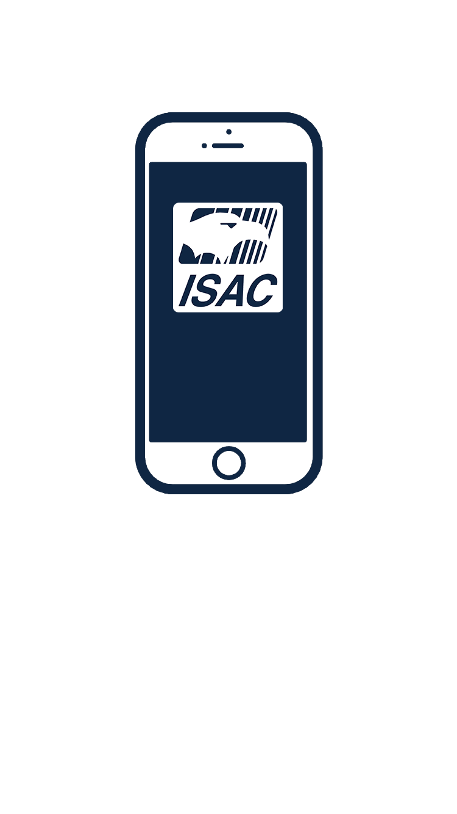

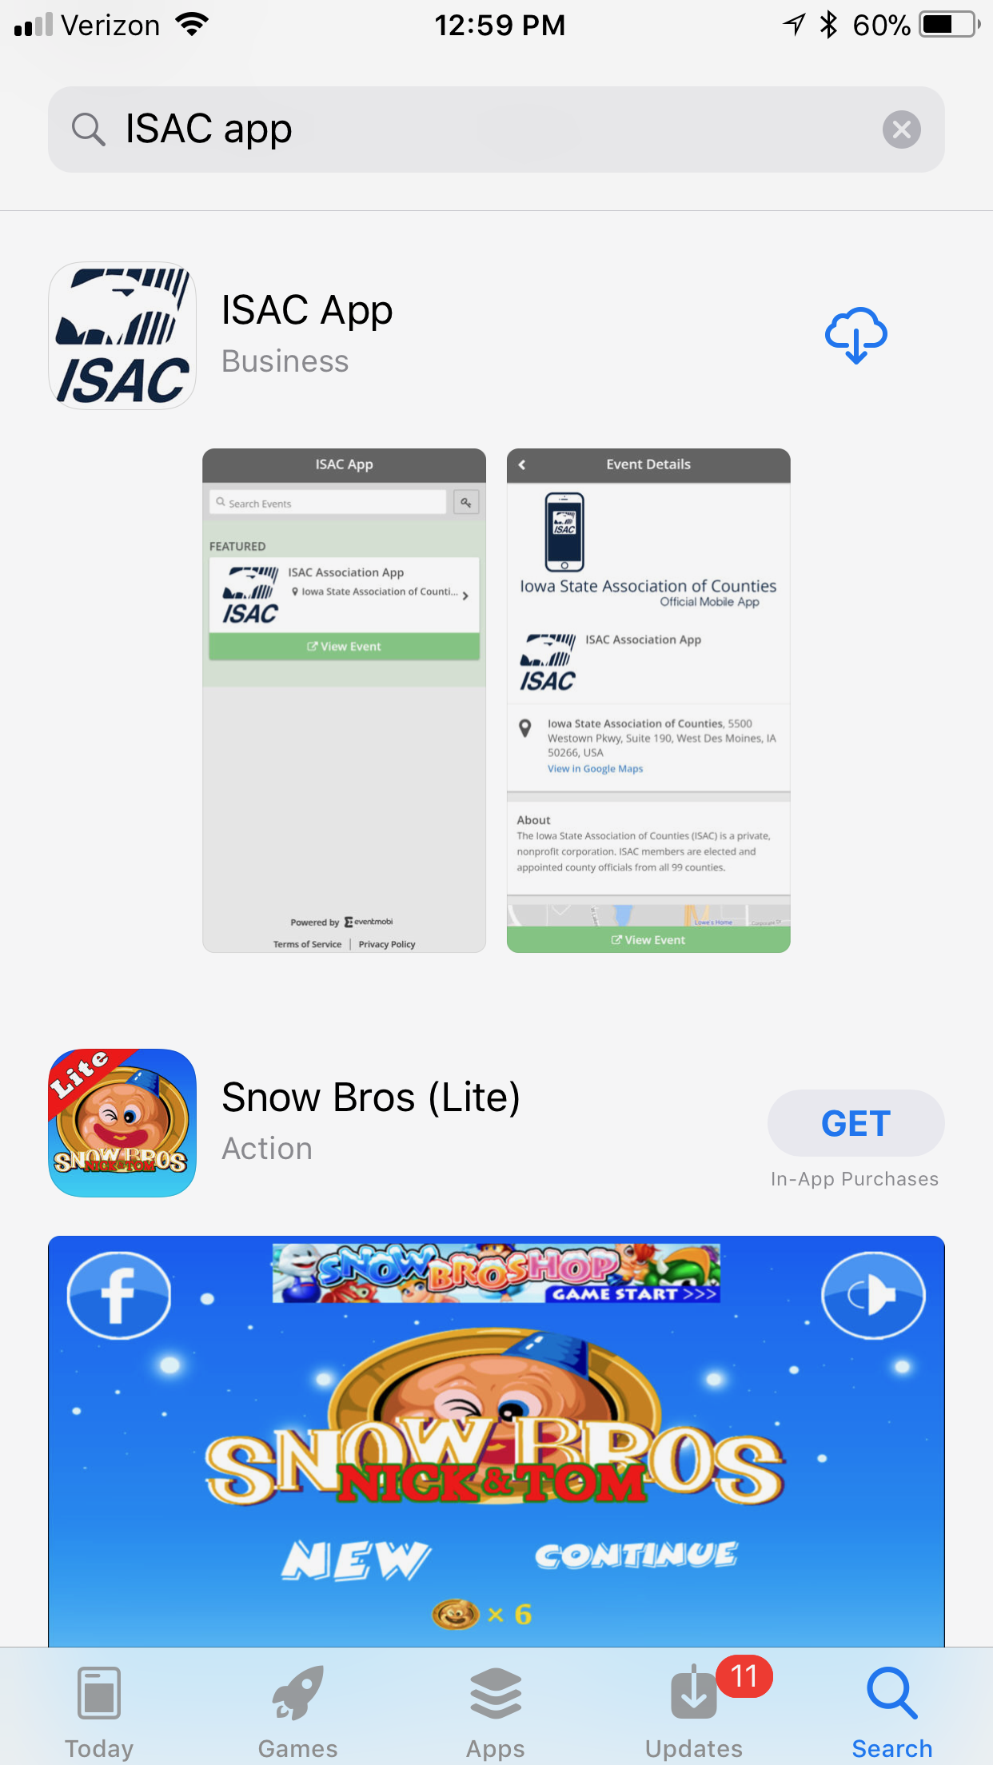

**Step 1:** Search “ISAC App” in the App or Google Play Stores. Our app will show a picture of the ISAC logo. Click to download to app.

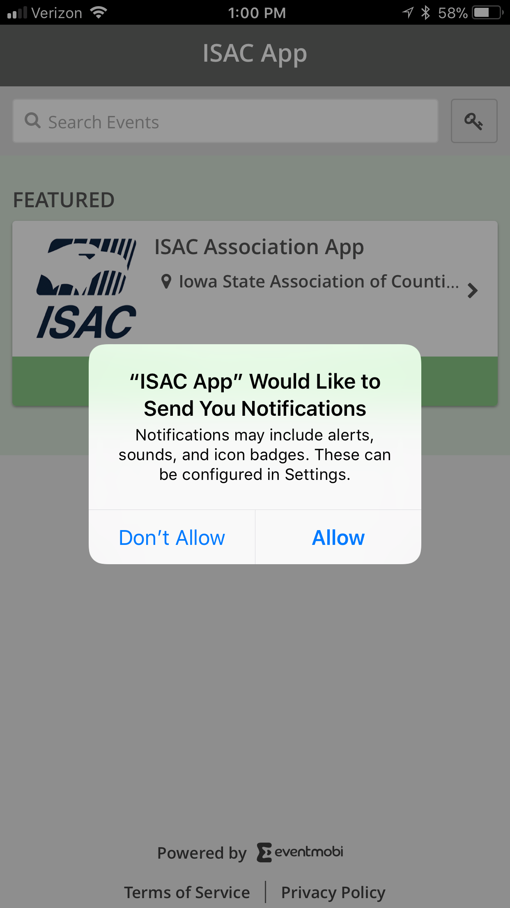

**Step 2:** Once you have downloaded and launched the app, make sure to allow our app to send you notifications. This will ensure that you receive important legislative and conference-related updates from ISAC.

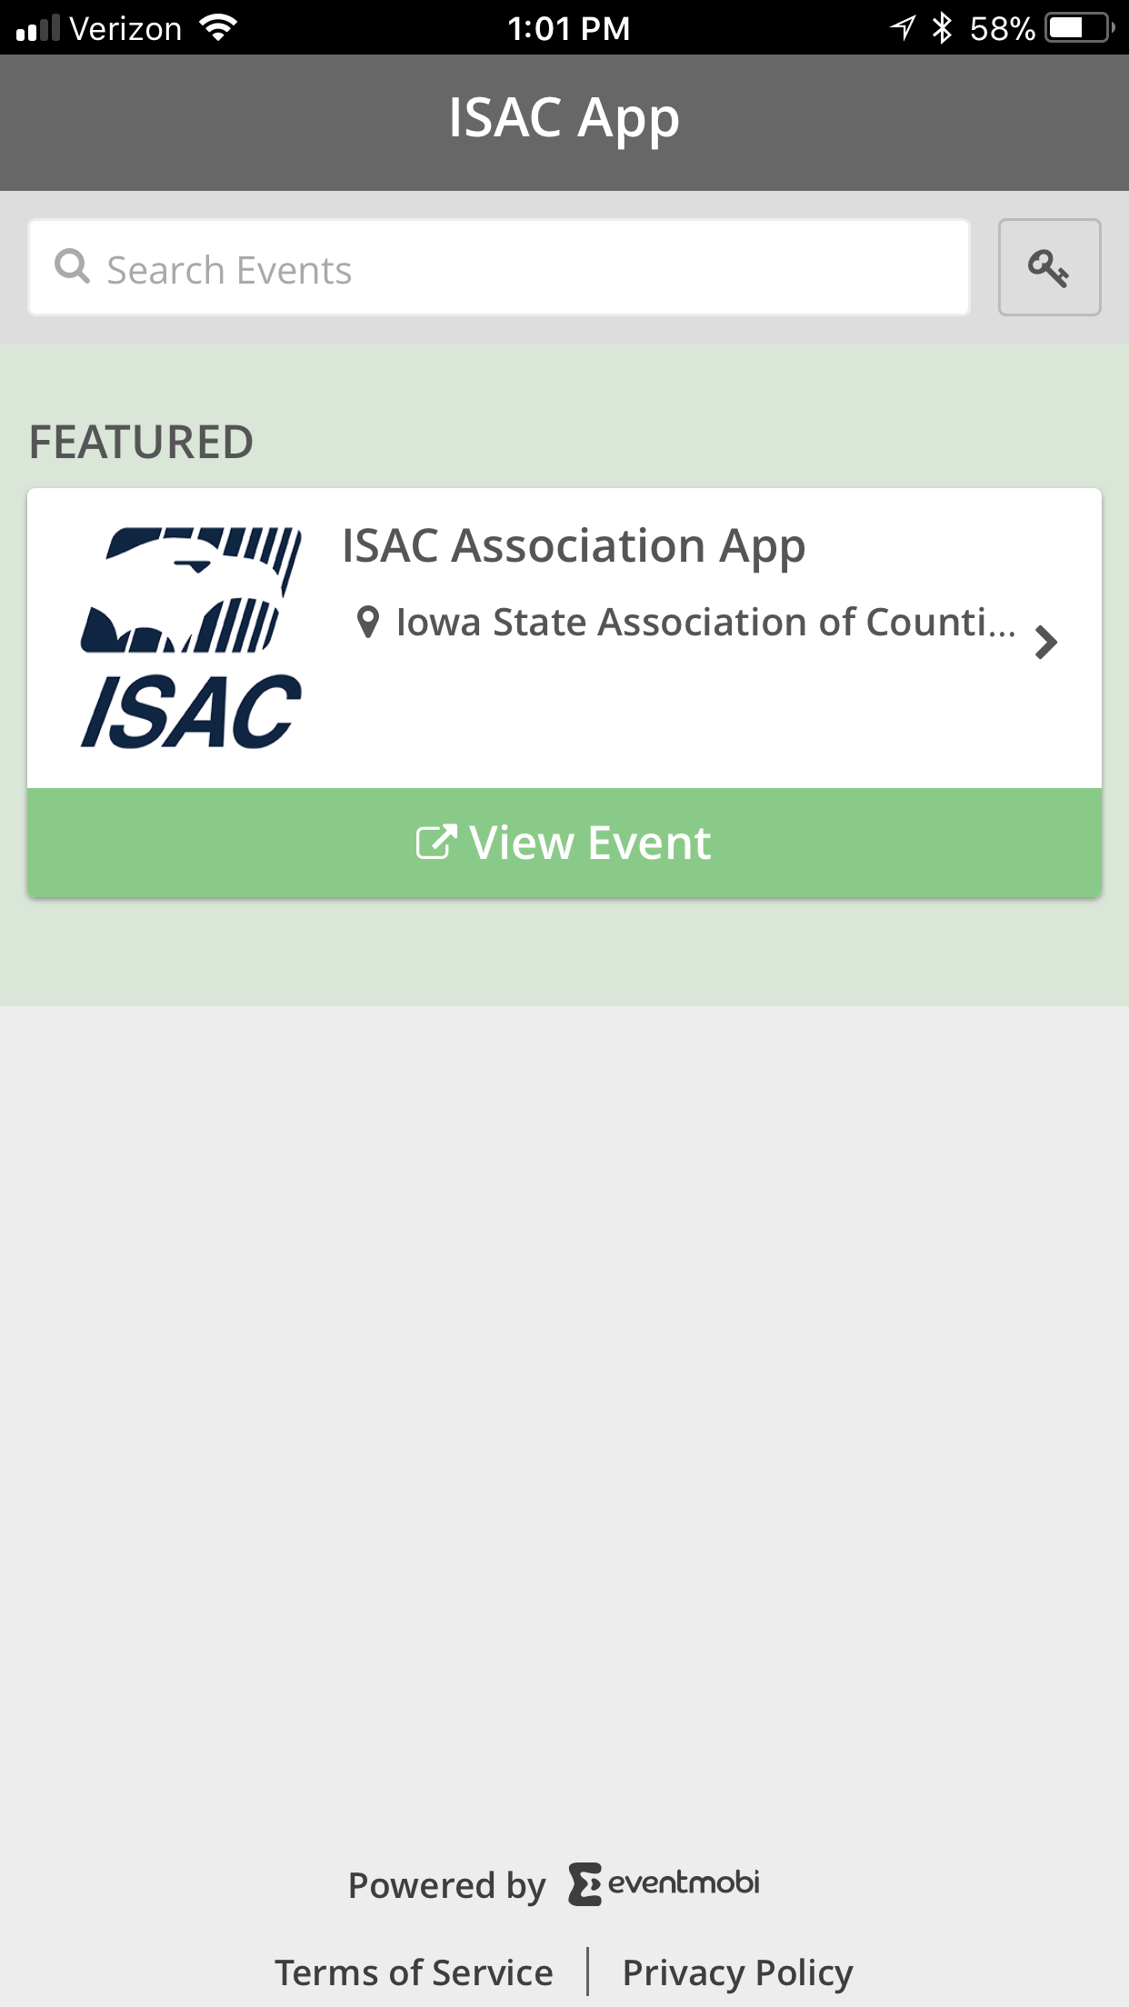

**Step 3:** Click “View Event.”

***Future Spring and Annual Conference apps will be located separately on this screen when they become active. You will no longer need to download new apps for each conference.

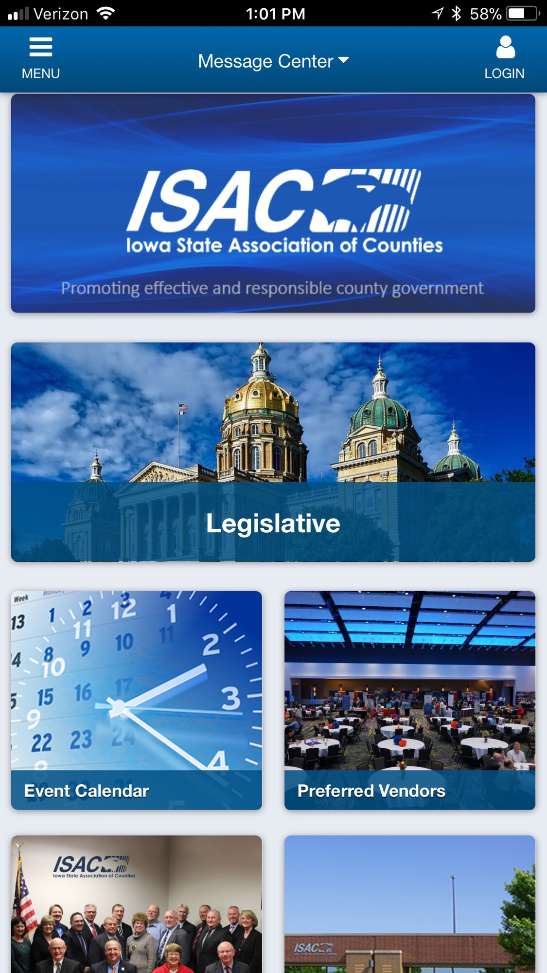

**Step 4:** This is the home screen of our app. This is where you can login and create your profile. Click “Login” in the upper right-hand corner.

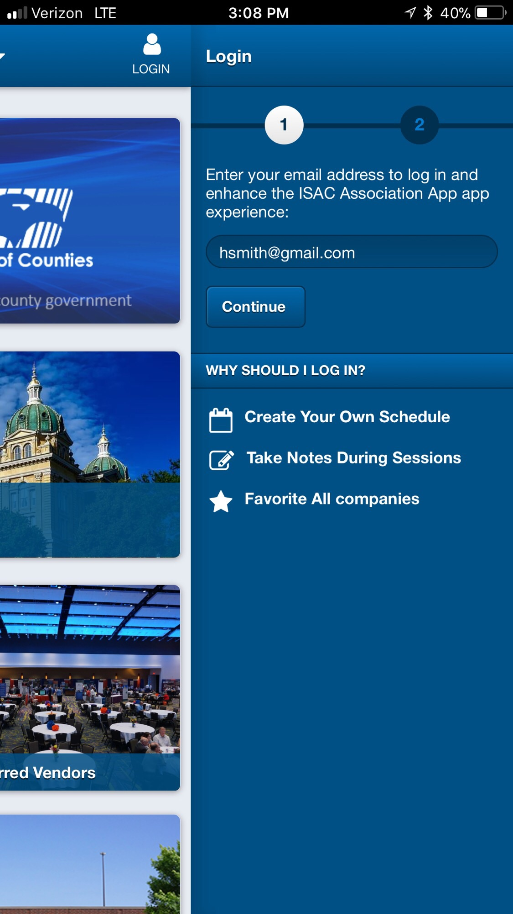

**Step 5:** Enter your email address and press “Continue.”

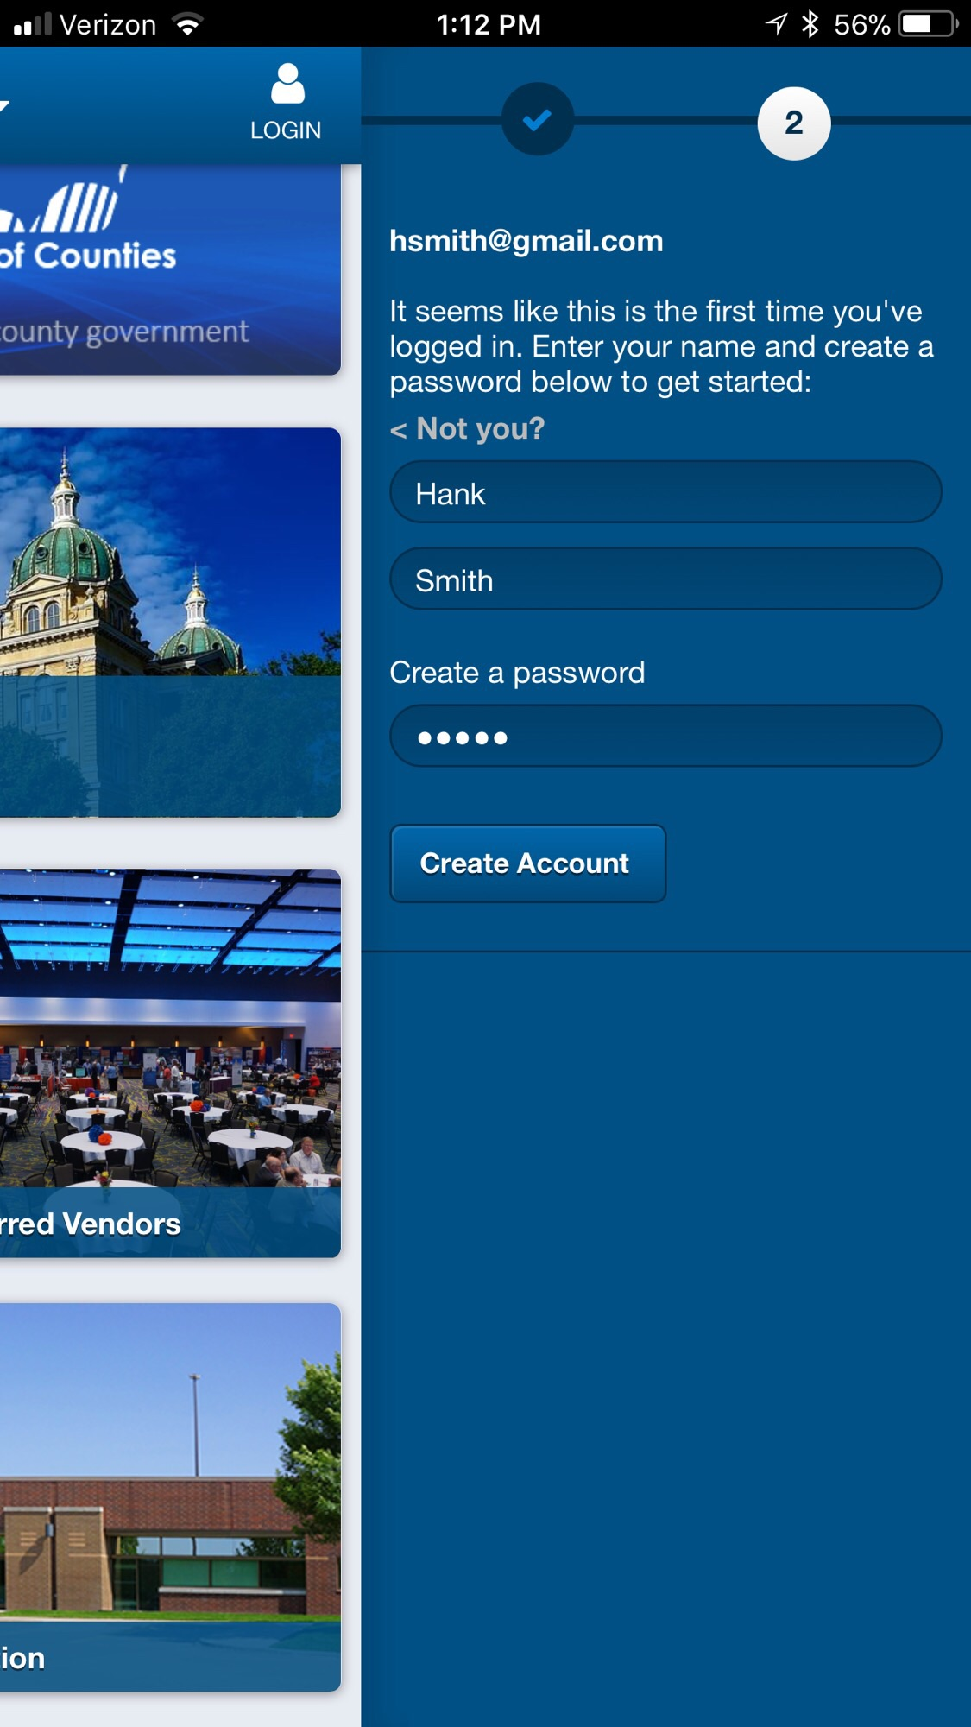

**Step 6:** Enter your first and last name, create a password, and press “Create Account.”

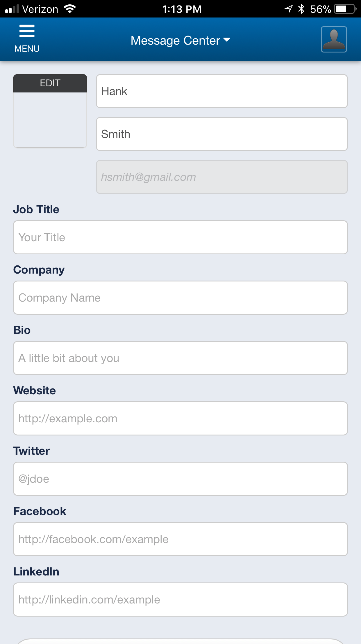

**Step 7:** Take a minute to customize your profile. Remember to click “Save your Profile” at the bottom of the screen.

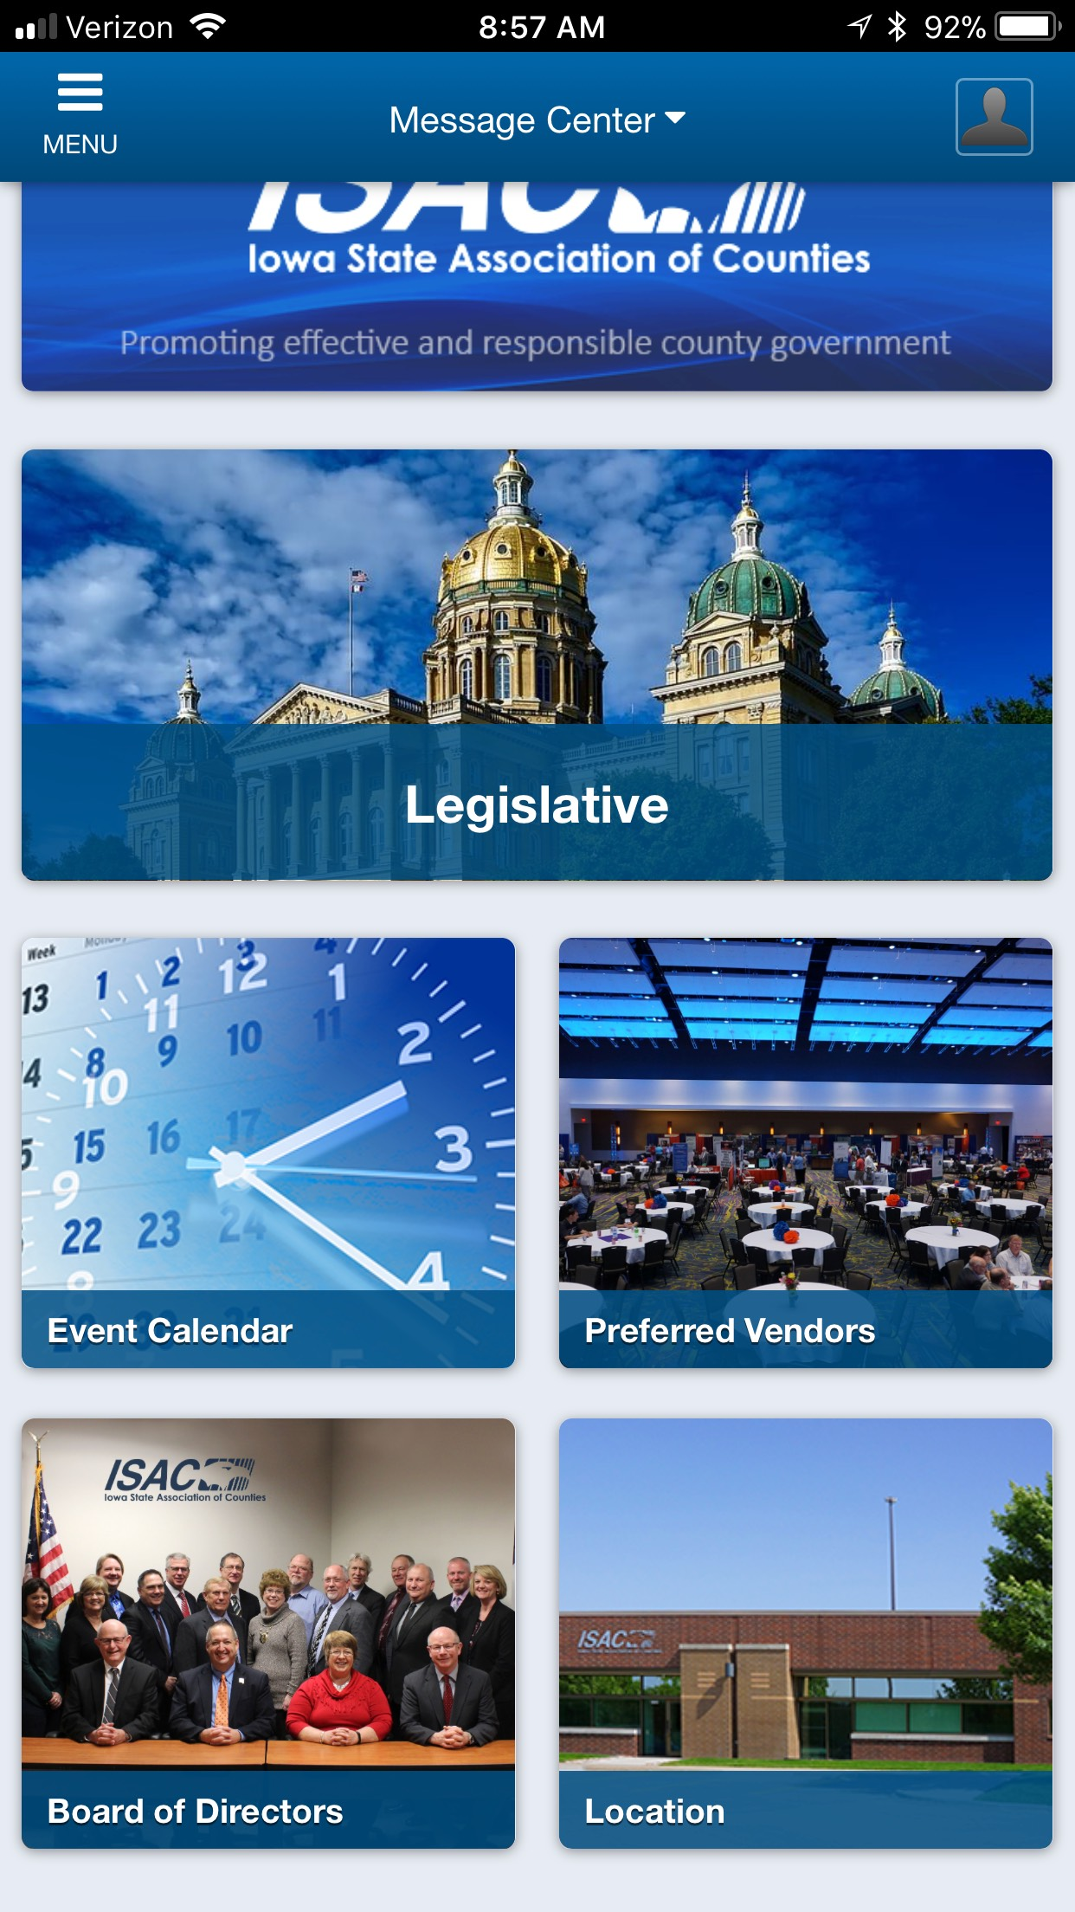

**Step 8:** Now that you are in the app take some time to explore its features. Frequently used sections are on the home screen. For more information click “Menu” in the upper left-hand corner.

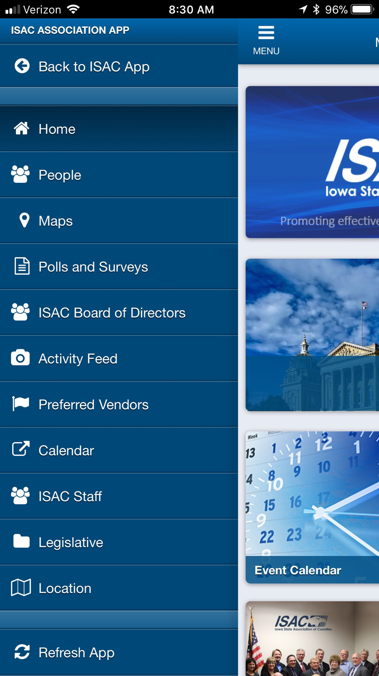

**Step 9:** The menu tab is where you will find key features. The “Activity Feed” and the “Calendar” are very useful.

***Please press “refresh app” in order to receive updated information on the app.

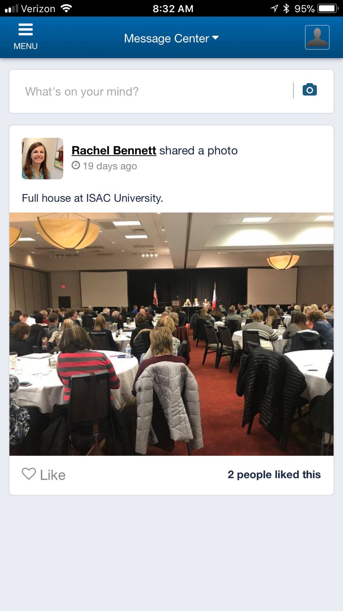

**Activity Feed:** Use the activity feed to share pictures and posts about ISAC meetings, events, and county news.

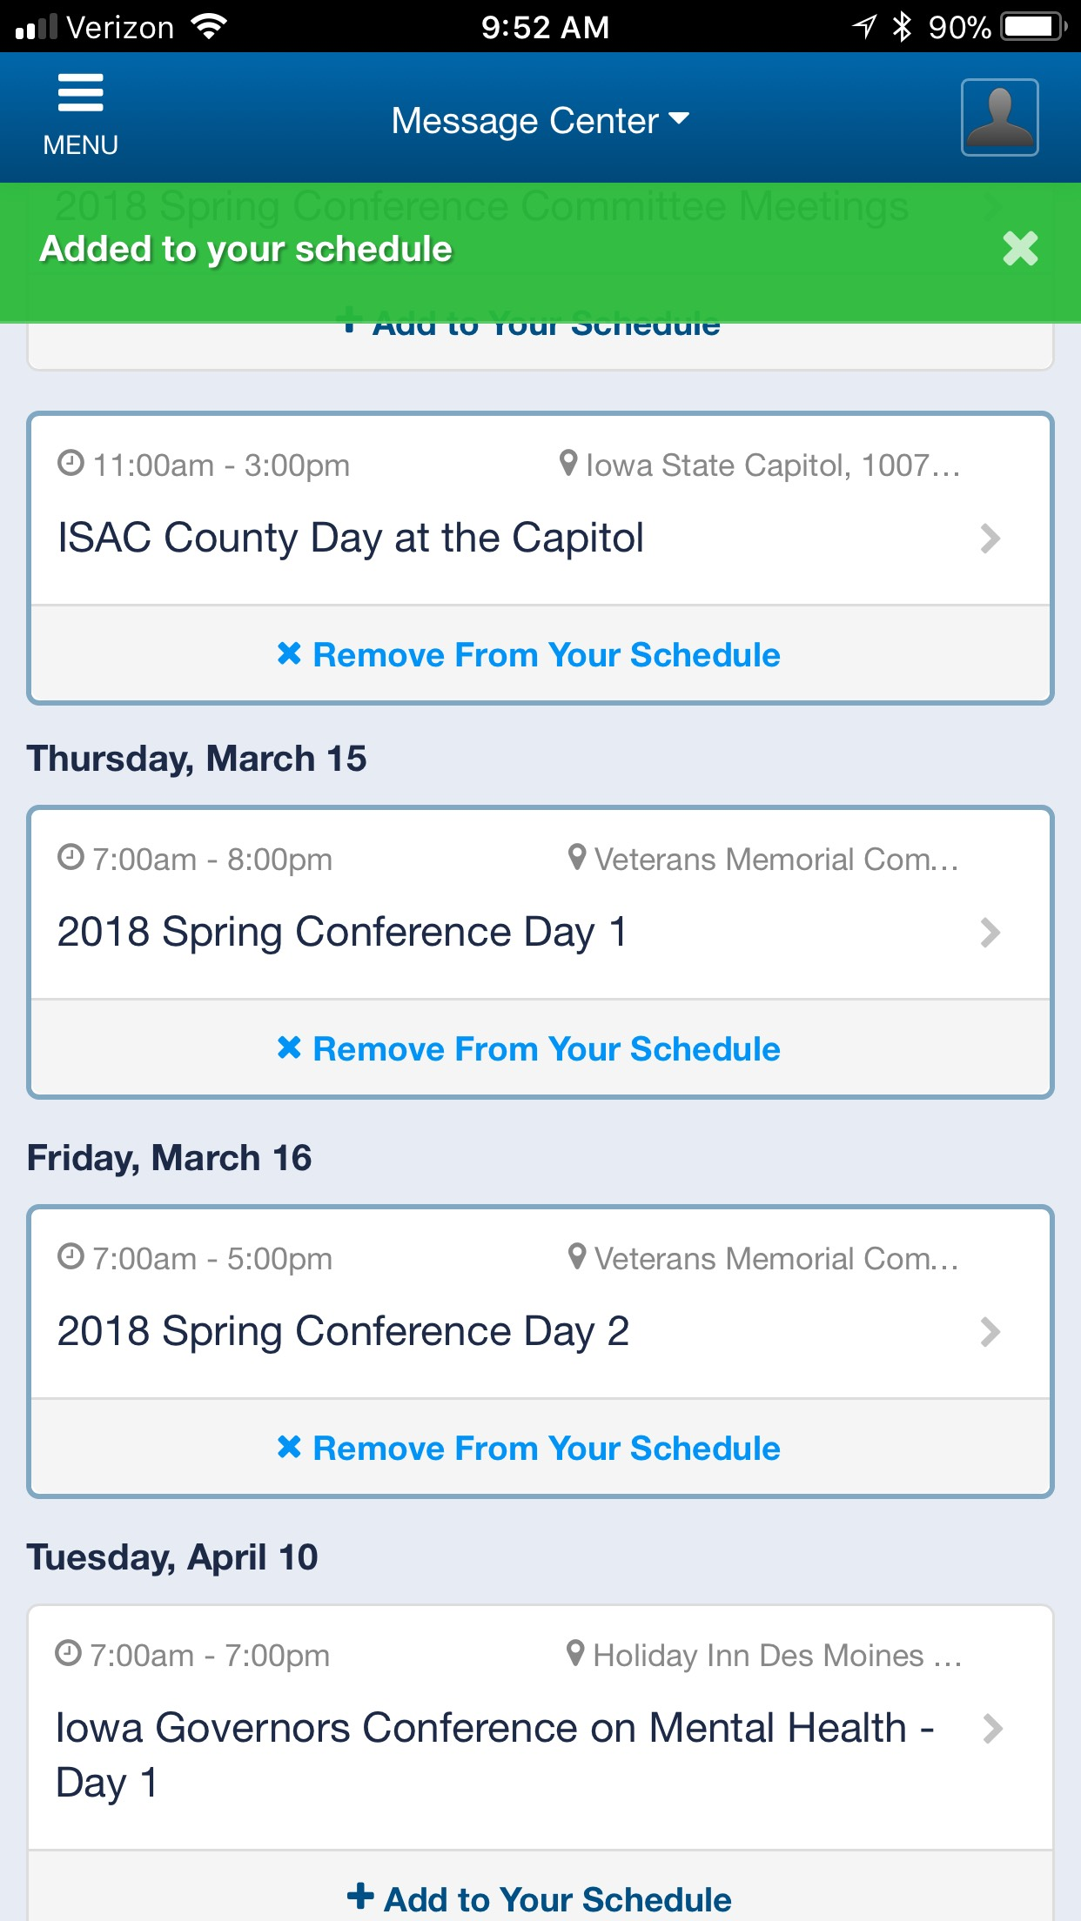

**Calendar:** From the calendar feature you can add events and meetings to your personal schedule. To add an event. Click “+ Add to Your Schedule.”

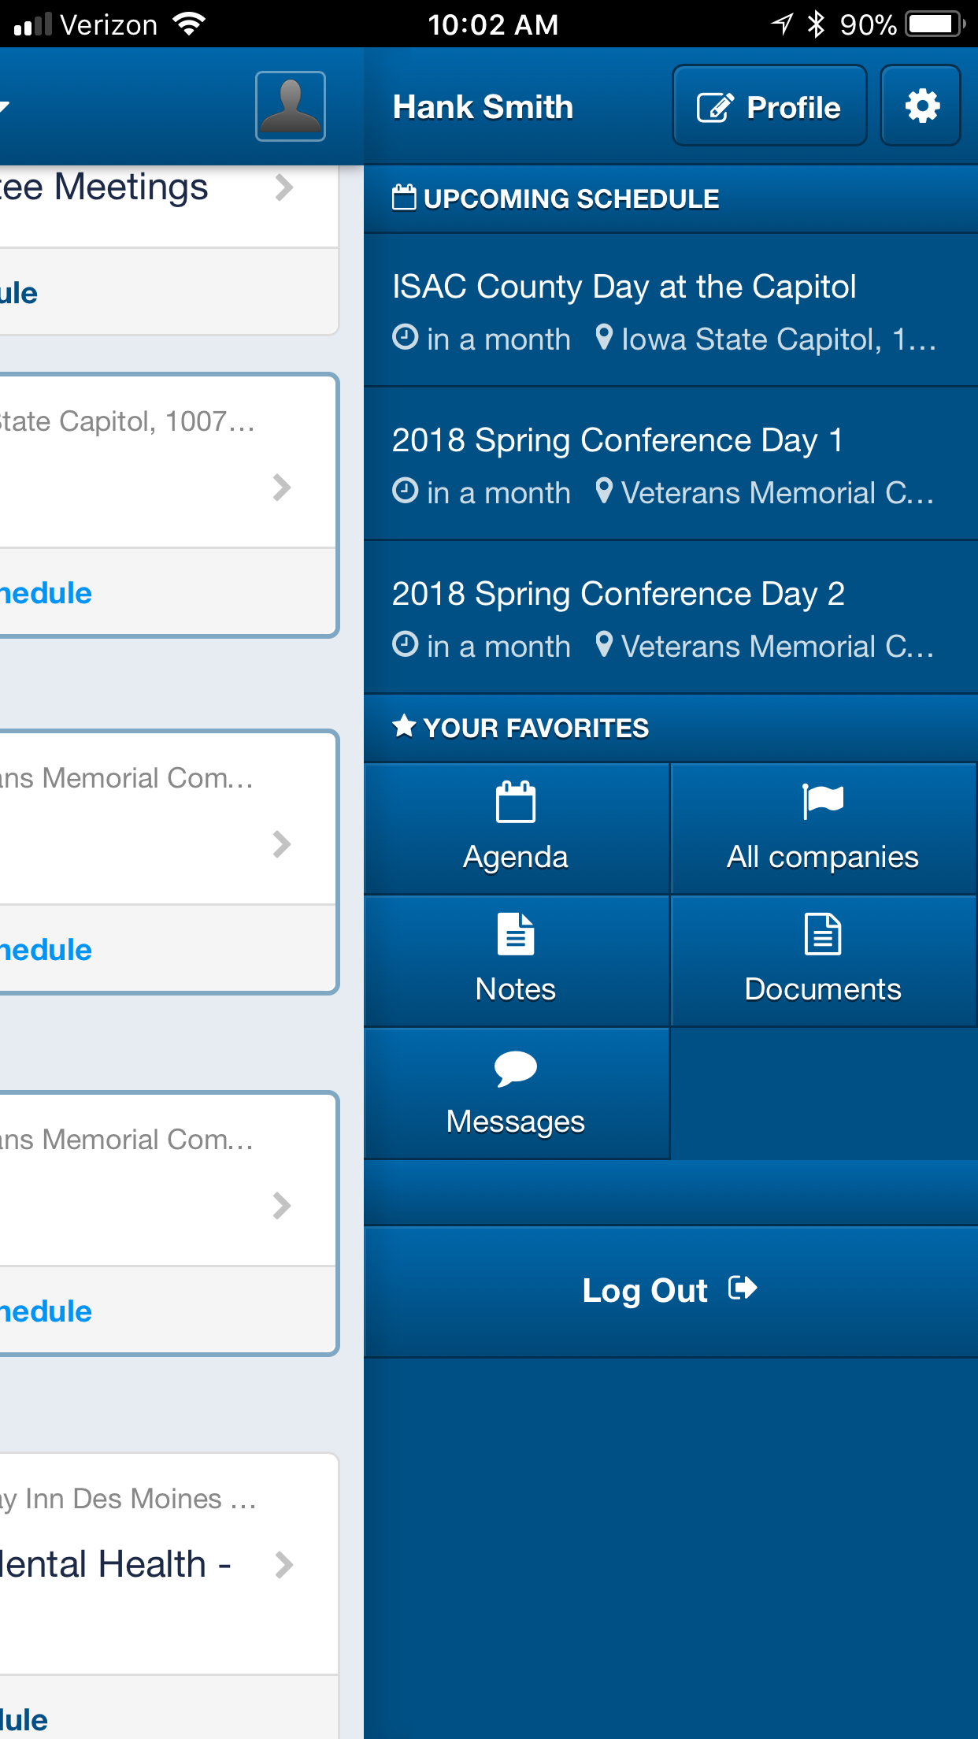

**Calendar:** The events you add will show up in your upcoming schedule when you click your profile in the upper right-hand corner.

***If you have any questions or concerns about the year-round ISAC association app please contact Jacy Bartling at [jbartling@iowacounties.org](mailto:jbartling@iowacounties.org) or 515.244.7181.