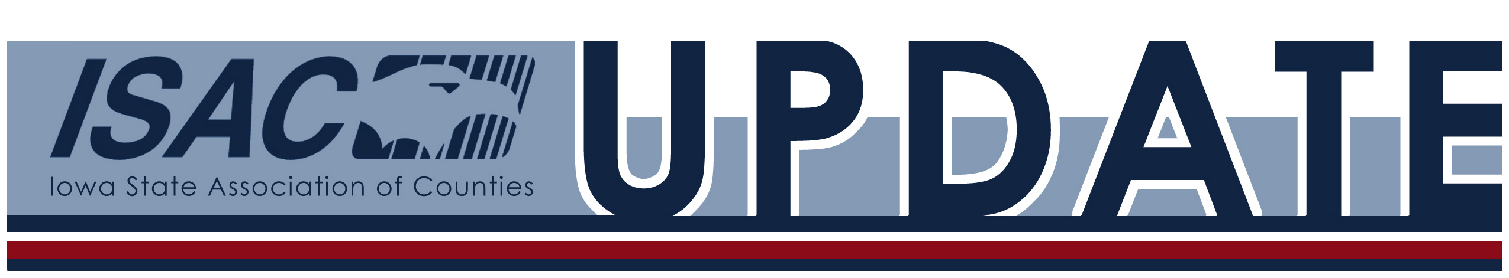
ISAC Legislative Update: 3.17.17

Connect with ISAC!


87th Iowa General Assembly, First Session, Week Ten
On Tuesday the Revenue Estimating Conference announced its projection of an additional $131 million shortfall in the FY 2017 state budget. Legislative leaders as well as the Governor have indicated that as this shortfall has come so late in the fiscal year, they will likely utilize some of the $738 million the state has in reserve funds to address the gap. The week ended on Thursday when the House concluded a lengthy debate on HF 518, changes to Iowa’s Worker’s Compensation Law. The Senate is expected to debate these changes at the beginning of next week.

• NEW Natural Resources and Outdoor Recreation Trust Fund
• NEW Federal Aid Road Fund Swap
• NEW Federal Tax Lien Records
• NEW Iowa’s Water Quality: A Public Health Perspective Workshop
• NEW Women with Political Inclination Seminar
• State and Local Legal Centers Midterm Webinar
• Legislative Tracking Tool
• Legislative Forums

New and Noteworthy
• 2017 ISAC Excellence in Action Awards – Call for Nominations
• ISAC Educational Webinar: Preservation with Purpose
• Derelict Building Grant Applications Due April 21
• IGFI Annual Workshops
• 2017 Iowa Employment Conference

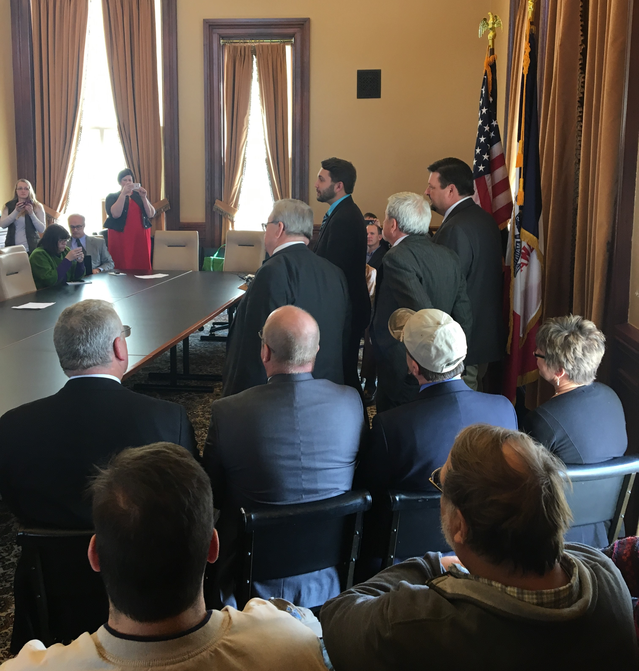
Natural Resources and Outdoor Recreation Trust Fund
On Tuesday, Representative Bobby Kaufmann along with 12 fellow House Republican co-sponsors introduced legislation that would fund the Natural Resources and Outdoor Recreation Trust Fund by increasing Iowa’s sales tax an 1/8 of a cent for three years which will eventually fund the trust at an estimated $180 million. The legislation is structured revenue neutral overall with corresponding income tax reductions by adjustments in the tax filing thresholds. As this is one of ISAC’s legislative priorities we were very pleased with this news, and we look forward to this being added to the debate of water quality improvements as this session concludes.

Click here to comment on this ISAC top priority.

Federal Aid Road Fund Swap
HF 203 passed out of the Senate on Monday. The bill allows the state to allocate primary road funds to counties and cities in exchange for federal aid road funds that would otherwise be allocated to the local governments. The federal fund swap is an ISAC legislative objective, and now goes to the Governor for final approval.

Click here to comment on federal aid road fund swap.

Federal Tax Lien Records
SF 439 passed out of the Senate on Wednesday. The bill allows original notices of federal tax liens to be returned to the sender or disposed of if they have been recorded in the index book or in digital form in the recorder’s office. The bill is an ISAC objective, and now goes to the House.

Click here to comment on federal tax lien records.

Iowa’s Water Quality: A Public Health Perspective Workshop
The Iowa Public Health Association will bring together a diverse array of professionals including local government officials to consider the challenges to Iowa's water quality through the lens of public health. The Iowa’s Water Quality: A Public Health Perspective workshop will be held from 11:30 am – 4:30 pm on Monday, April 10 in Des Moines. Click here to download an informational flier, and click here to register now. Please contact Jeneane Moody at iowapha@gmail.com or 515.491.7804 with any questions.

Women with Political Inclination Seminar
Women with an eye to serving in the Iowa Legislature have a unique opportunity to explore the possibilities on March 28-29 when 50-50 in 2020 holds its annual “See Yourself Here” seminar at the State Capitol. Co-sponsored by the Carrie Chapman Catt Center for Women and Politics at Iowa State University, the two-day program is designed to familiarize potential lawmakers with the Capitol’s layout and legislative routine, while also introducing them to the legislative leaders of both parties, staff, lobbyists and media members. A $30 seminar fee includes all materials and the Tuesday night reception and dinner at the Hotel Fort Des Moines. Participants are responsible for their transportation, overnight accommodations and any additional meals. Registration is required and is available through the 50-50 in 2020 website: www.50-50in2020.org.

50-50 in 2020 is an issue-neutral, not-for-profit organization working to help women from all political parties and parts of the state run for office. It is the only bipartisan, issue-neutral group in America working for election of women to political office. It is not a political action committee, nor does it endorse candidates.

State and Local Legal Centers Midterm Webinar
The State and Local Legal Centers (SLLC) will be holding a Midterm Webinar at 1:00 pm on March 30. Click here to register. The Supreme Court’s 2016-17 docket is set. While the Court is still down a Justice and will decide fewer cases than usual this term, it will decide many cases of interest to states and local governments including a number of police cases, First Amendment cases, and a preemption case. Join Matt Wessler, Gupta Wessler, who argued the preemption case, Tom Bondy, Orrick, who co-wrote the merits brief for Los Angeles county in the most important police case of the term, and Lawrence Hurley, Supreme Court correspondent for Reuters, in a discussion of the cases and the future of the Court.

Legislative Tracking Tool
One of the important duties of the ISAC legislative team during session is to track legislation that is significant to counties. ISAC members can access these bills via our online tracking tool that provides links to the bills, affiliate affected, ISAC staff monitoring, and ISAC position. This can be found here: http://www.iowacounties.org/legislative/tracking-tool/.

Legislative Forums
Most legislators conduct forums back in their home districts on Fridays and on the weekends to seek constituent feedback on a variety of topics. We strongly encourage ISAC members to attend these forums as these are effective tools to advance and address issues that are vital to counties. A link to these forums can be found here:

http://www.iowahouserepublicans.com/forums

http://iowahouse.org/forums/

http://www.senate.iowa.gov/democrats/events/

http://www.iowasenaterepublicans.com/events/

Click here to comment on bills, legislative interaction, etc. This legislative comment form is convenient to use and allows ISAC to receive feedback that is extremely helpful.

2017 ISAC Excellence in Action Awards - Call for Nominations
The Excellence in Action Award program is a competitive awards program that seeks to identify and recognize innovative county government employees, programs, and ISAC affiliates. Please encourage all county departments to apply. Awards will be presented at the 2017 ISAC Annual Conference which is being held August 23-25 in Des Moines.

Click here to download the nomination form that contains details regarding criteria, guidelines and judging. This page also contains information and materials from past award winners. Please contact Robin Harlow, ISAC’s Innovation and Research Manager, at 515.369.7006 or rharlow@iowacounties.org with any questions.

ISAC Educational Webinar: Preservation with Purpose
Join representatives from Madison County from 2:00 pm – 3:00 pm on March 22 as they present Preservation with Purpose: How Historic Preservation Can Make a Tangible Difference in Your County. Click here to register!

Historic preservation is uniquely positioned to capitalize on a community’s historic character, boost economic development and build local pride. In Iowa, two dozen county governments have established historic preservation programs and participate in the National Park Service’s Certified Local Government Program for Historic Preservation. This webinar will explain how the program works and the potential benefits to your county. Madison County, which has a model preservation program, will be discussed as a case study. The chairs of the Madison County Board of Supervisors and the Madison County Historic Preservation Commission will share how they have used the program and how preservation has made a positive difference in their county. Presenters include: Brenda Hollingsworth, Madison County Historic Preservation Commission; Paula Mohr, State Historical Society of Iowa; and Aaron Price, Madison County Board of Supervisors.

Derelict Building Grant Applications Due April 21
Small rural communities looking for assistance to help renovate or deconstruct abandoned commercial and public structures can apply for funding through the Derelict Building Grant Program. Applications for the next round of funding are due at 4:00 pm on April 21.

The grant program, instituted by state legislation, helps rural Iowa communities with populations of 5,000 or less to deconstruct or renovate abandoned commercial and public structures. The program emphasizes reuse and recycling of building items, helps improve street appearance and commercial development, and alleviates the environmental concern these buildings can pose. Financial assistance includes asbestos removal, building deconstruction and renovation, and other environmental services.

Funding is awarded annually on a competitive basis. A committee from the Iowa DNR, Iowa Society of Solid Waste Operations, Iowa Recycling Association, Iowa Economic Development Authority and Keep Iowa Beautiful selects the projects for funding. For more information and to obtain an application on the Derelict Building Grant Program, contact Scott Flagg at 515.725.8318 or Scott.Flagg@dnr.iowa.gov.

IGFI Annual Workshops
The Iowa Government Finance Initiative (IGFI) is holding “tool-based trainings” across the state for elected and appointed officials on issues relating to public finance and community and economic development. Click here to register online, for an event brochure and for all workshop details. The training dates and locations are as follows:
April 6 – Ottumwa
April 13 – Storm Lake
April 20 – Altoona/Des Moines
April 27 – Mason City
May 4 – Atlantic
May 18 – Cedar Rapids

2017 Iowa Employment Conference
The 2017 Iowa Employment Conference which covers employment, training, benefits and wellness will be held on April 5-6 at The Meadows Events and Conference Center in Altoona. This two-day conference will feature leaders in employment and labor laws from around the Midwest who will present on timely and important topics for employers, including ACA updates, immigration law, harassment and retaliation developments, employee mental health and more. Click here for more information and to register.

Contact Information:
Iowa State Association of Counties (ISAC)
5500 Westown Parkway, Suite 190, West Des Moines, IA 50266
Phone: 515.244.7181 Fax: 515.244.6397
www.iowacounties.org
This ISAC Update is being sent to all ISAC members.

