(# of Years)
Years of Service

We hereby express our sincere appreciation to

(Insert Name)

for dedicated service to
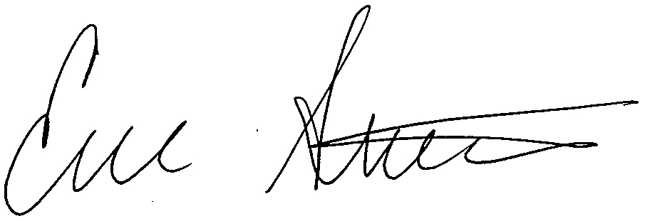
(insert County) County government.
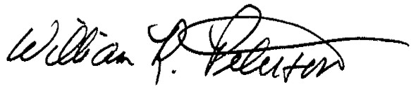
_________________ ____________________
ISAC President ISAC Executive Director
2019

